**Data Visualization Associate**

**Internship**

**Team No.: 37**

**WEEK 02**

**Team Lead:** Clarke Ambia

**Project Manager:** Farwa Rashid

**Project Scribe:** Adarsh Raj Tiwari

**Project Lead:** Alishba Waqar

|  |  |
| --- | --- |
| **Team Members** | **Emails** |
| Clarke Ambia | clarkambia@gmail.com |
| Farwa Rashid | farwarashid785@gamil.com |
| Adarsh Raj Tiwari | myselfadarsh01@gmail.com |
| Alishba Waqar | alishbawaqar7786@gmail.com |
| Ashwitha Kota | kotaashwitha16@gmail.com |
| Ayush Choudhary | ayushkumar86966@gmail.com |

1. **Looker Studio Dashboard**

**Looker Studio Dashboard – Supabase:**

This dashboard highlights metrics such as Connected Calls, Disconnected Calls, Connectivity Rate, Agent Performance, Campaign Data, and Country-based Analysis. Interactive elements such as filters and drilldowns are included.

Live Dashboard Link: <https://lookerstudio.google.com/u/0/datasources/6b7d00d3-8f42-4dd8-bb8b-47c292a2ee11>

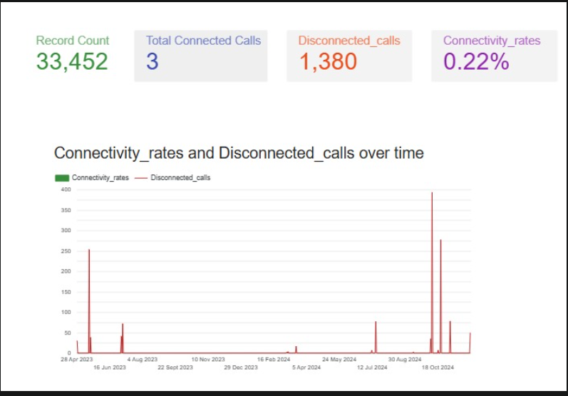

**Figure 1: Dashboard Through Supabase**

This view shows the dashboard connected to the Supabase PostgreSQL database.

**Looker Studio Dashboard – Aiven:**

This dashboard highlights metrics such as Connected Calls, Disconnected Calls, Connectivity Rate, Agent Performance, Campaign Data, and Country-based Analysis. Interactive elements such as filters and drilldowns are included.

Live Dashboard Link: <https://lookerstudio.google.com/reporting/348626d1-bf84-44cc-99f1-453c387b807a>

**Figure 2: Dashboard Through Aiven**

This view shows the dashboard connected to the Aiven PostgreSQL database.

1. **Proof of Data Connection**

**Supabase PostgreSQL:**

The PostgreSQL database is hosted on Supabase. Connection details such as Host, Port, Database Name and User were obtained from the Supabase dashboard.

**Aiven PostgreSQL:**

The PostgreSQL database is hosted on Aiven Cloud. Connection details such as Host, Port, Database Name, User, and SSL mode were obtained from the Aiven console.

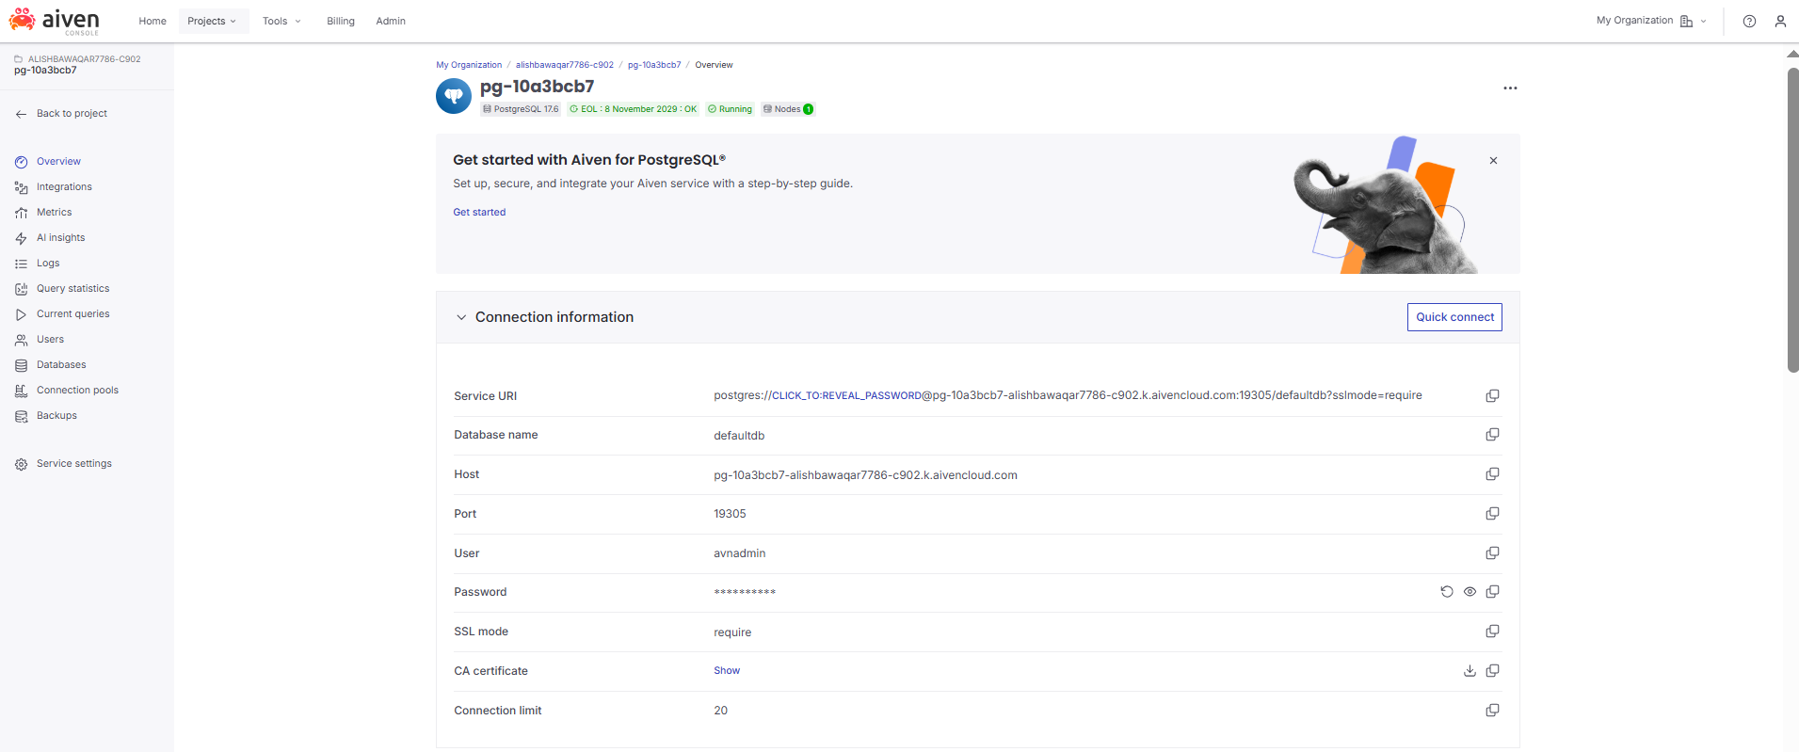

**Looker Studio Data Source:**

Both Aiven and Supabase PostgreSQL databases were added as data sources in Looker Studio. The connections show "Status: Connected", confirming that live queries can be run.

**Looker Studio Data Source Screenshot-supabase**

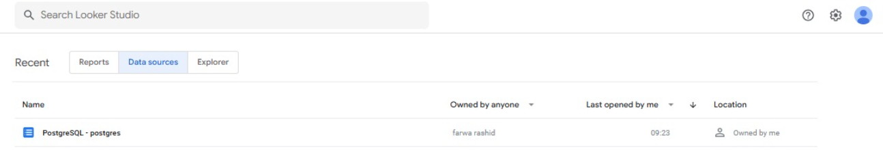

**Looker Studio Data Source Screenshot-Aiven**

**Connection Confirmation:**

The data source connections were successfully established between Looker Studio and both Aiven & Supabase PostgreSQL databases. Verified by visible schema fields and live table previews.

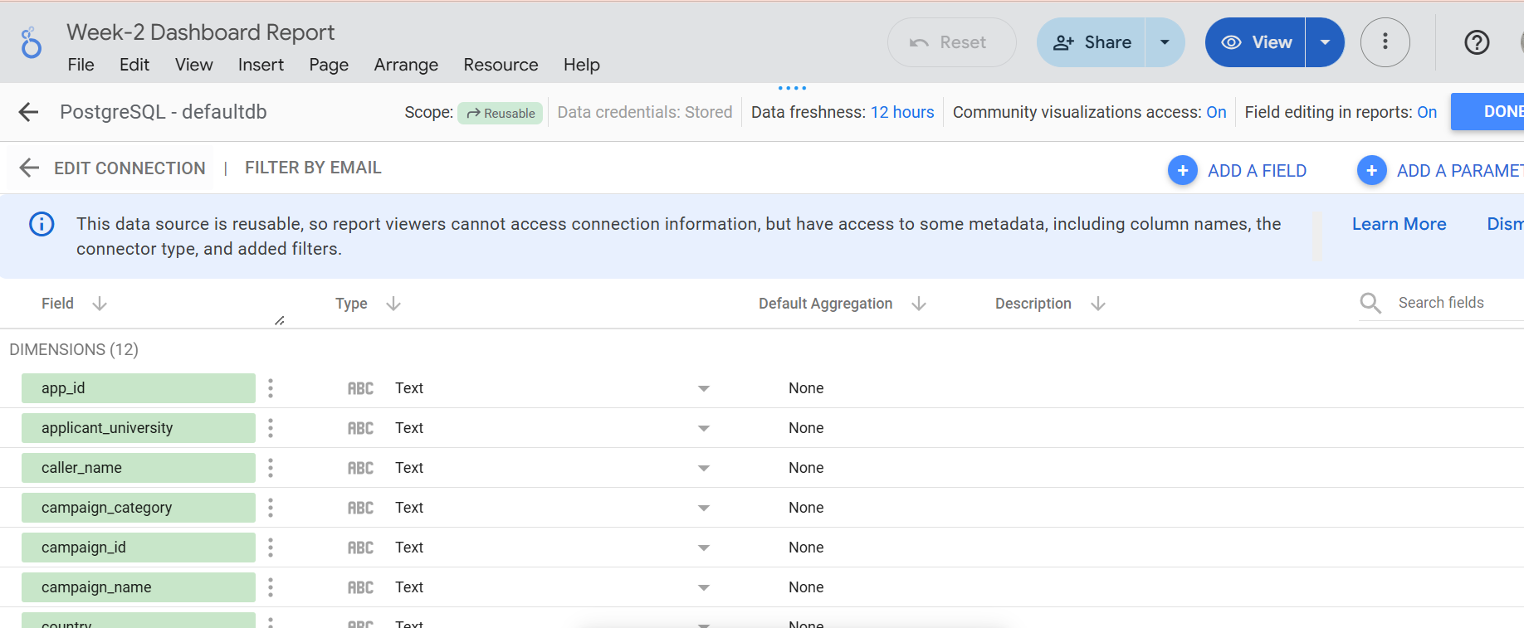

1. **Design Documentation:**

**Chart Types**

* Looker Studio-Supabase:
  + Line Chart → Connectivity rates & disconnected calls over time.
  + Line Chart → Agent performance trends over time.
* Looker Studio-Aiven:
  + Bar Charts (Agent Performance, Campaign Outcomes).
  + Pie Charts (Campaign Category, Calls by Country).

**Colour Scheme:**

* **Background:** #16423C → *Dark Slate Green*
* **Sections/Charts:** #6A9C89 → *Sage Green*
* **Text:** #C4DAD2 → *Light Grayish Green*

**Layout Decisions:**

* **Looker Studio-Supabase:**
  + KPIs (Record Count, Connected Calls, Disconnected Calls, Connectivity Rate) shown at the top.
  + Line chart for connectivity trends.
  + Separate line chart for agent-wise performance.
* **Looker Studio-Aiven:**
  + All KPIs (Record Count, Connected Calls, Disconnected Calls, Connectivity Rate) shown at the top.
  + Below: Combination of bar and pie charts for detailed insights.
  + Filters for **country** and **date range** included.

**Storytelling Approach: (Figure-1)**

**Overview**

* At the very top, you show the big numbers (KPIs): Record count, Connected Calls, Disconnected Calls, Connectivity Rate.
* Using colours (green for good, red for critical, purple for rates) makes it intuitive for decision-makers.

**Trends → What’s Happening Over Time**

The line chart shows patterns:

* Spikes in disconnected calls.
* Connectivity rate staying low.
* This helps decision-makers see when issues occur, not just the totals.

It shifts the story from “just numbers” to timeline insights.

**Actionable Recommendations**

From your current screenshot, recommendations might be:

* Improve connectivity rate (0.22% is very low): Train agents or check technical issues.
* Investigate high disconnections (1,380): Focus on peak times shown in the timeline.
* Highlight positive agent/country performance (once filters are added): Reward best performers.

This closes the loop → not just showing data but guiding decisions.

**Storytelling Approach: (Figure-2)**

**High-Level KPIs (Top Section)**

Record Count, Connected Calls, Disconnected Calls, Connectivity Rate

**Filters (Country + Date Range)**

* Adding filters empowers users to slice the data interactively.
* For example, managers can check performance by country or specific campaign dates.
* This is good user-centric design, since not all stakeholders want the same view.

**Agent Performance (Bar Chart)**

* Shows which agents handle the highest call volume (Rufina, Pragati, Jyoti).
* But it also compares connected vs disconnected calls → highlights performance differences.
* Story: Some agents are handling a lot of calls, but connections remain low → training/technical fixes needed.

**Calls by Campaign Category (Pie Chart)**

* 78.8% Post Admission, 21.2% Pre Admission.
* This tells decision-makers where most effort is going → majority of outreach is after admission.
* Actionable insight: If pre-admission conversions are critical, resource allocation might need rebalancing.

**Calls by Campaign with Outcome (Bar Chart)**

Breaks down campaigns by outcomes (Not Connected, Will Submit Docs, Disconnected, Wrong Number).

This adds qualitative storytelling:

* Not just how many calls, but what happened in those calls.
* E.g., Campaign G2-QS-G2C has the highest “Not Connected” calls.
* Managers can decide which campaigns to optimize or redesign.

**Calls by Country (Pie Chart)**

* India leads with 32.6%, followed by Unknown (20.1%), Ghana (11.6%), Nigeria (10.1%), Pakistan (3.7%).
* Regional insights → Managers can focus on countries with highest disconnections or lowest connectivity rate.
* Actionable: Maybe improve infrastructure/agents for Ghana & Nigeria (since they’re big contributors but lower conversions).

**Overall Storyline**

Our dashboard follows a logical flow:

* Big Picture → KPIs (Total calls, connected, disconnected, connectivity).
* Who is Responsible? → Agent performance.
* Where are the Calls Going? → Campaign category & outcomes.
* Where in the World? → Country distribution.
* This flow takes the viewer from macro → micro insights, which is exactly how storytelling in dashboards should work.

**Actionable Recommendations**

From your charts:

* Train/review top agents → Rufina & Pragati manage huge volumes but need better connection strategies.
* Fix campaigns with high disconnections → especially “G2-QS-G2C.”
* Focus on top countries (India, Ghana, Nigeria) for better outcomes.
* Investigate 20% “Unknown” country data → possibly incomplete records in the database.